

Europass  Curriculum Vitae |  | 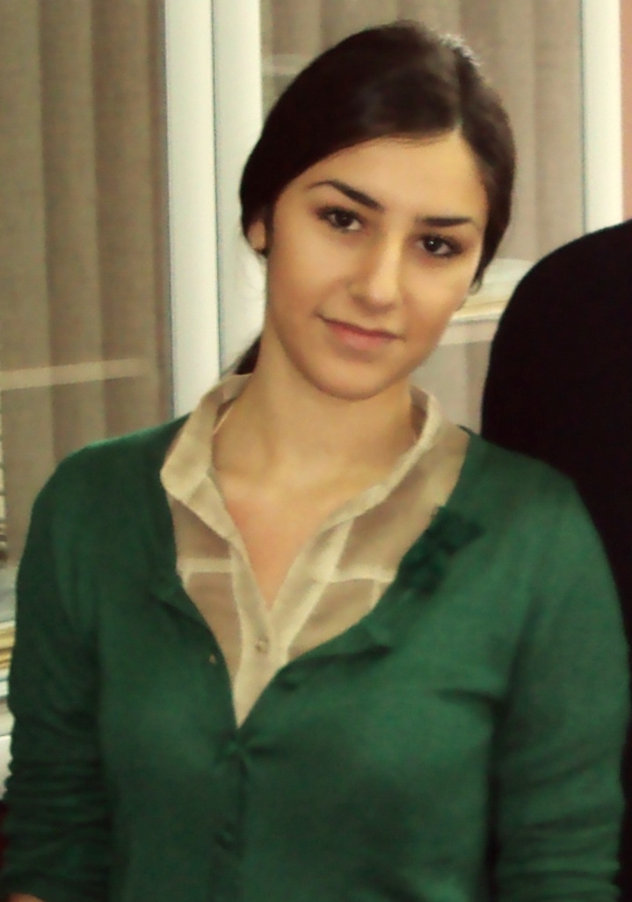
Personal information
First name(s) / Surname(s) |  | Marina Jovanova
Address(es) |  | Blagoj Josmov br. 18
Telephone(s) |  | Mobile: +38970532318
Fax(es) |  | /
E-mail |  | marina.jovanova@live.com
Nationality |  | Macedonian
Date of birth |  | 21 October 1989
Gender |  | Female
Desired employment / Occupational field |  | Accounting, Financial Analysis, Office Work and Billing
Work experience
Dates |  | September 2012 – May 2013
Occupation or position held |  | Accountant
Main activities and responsibilities |  | Booking of Lead Schedules, Invoices, Entry Registration Documents, Receipts, Transfers, Compensation Transactions, Warehouse Stocks, etc.
Name and address of employer |  | Accounting Bureau “AKSA”, ul. Blagoj Gjorev
Type of business or sector |  | Accounting firm
Work experience
Dates |  | June 2013- in progress
Occupation or position held |  | Ekonomist
Main activities and responsibilities |  | Making outbound invoices, Jessie, compensation, warehouse inventory records, work on fiscal, material records of incoming and outgoing invoices in excel and keeping the material accounting.
Name and address of employer |  | Agrar Trejd DOOEL Veles
Education and training
Dates |  | September 2004 – June 2008
Title of qualification awarded |  | Completed High School Education – Social and Humanistic Sciences - A
Principal subjects/occupational skills covered |  | Mathematics, English language, Management, Business and Economy…
Name and type of organisation providing education and training |  | Gymnasium “Koco Ratcin” - Veles
Level in national or international classification
Dates |  | 15 September 2008 – 02 February 2013
Title of qualification awarded |  | Bachelor of Economics
Principal subjects/occupational skills covered
Name and type of organisation providing education and training |  | Faculty of Economics “Cyril and Methodius” - Skopje
Level in national or international classification |  | /
Personal skills and competences |  | Loyalty,initiative, dedication, thoroughness, patience, positive attitude, creativity, honesty, ambition, inventiveness, good communication skills, efficient and representative.
Mother tongue(s) |  | Macedonian
Other language(s)
Self-assessment |  |  | Understanding |  |  |  |  | Speaking |  |  |  |  | Writing
European level (*) |  |  | Listening |  | Reading |  |  | Spoken interaction |  | Spoken production
English |  |  |  | Yes |  | Yes |  |  | Yes |  |  | Yes |  | Yes
Spanish |  |  |  | Yes |  | Yes |  |  | Yes |  |  | Yes |  | Yes
Serbian |  |  |  | Yes |  | Yes |  |  | Yes |  |  | Yes |  | Yes
 |  | (*) Common European Framework of Reference for Languages
Social skills and competences
Organisational skills and competences
Computer skills and competences |  | Microsoft Office (Word, Excel, Power Point), EViews 6, Internet, working with Outlook Express, Corel, Photoshop, ability to type quickly.
Projects |  | Correlation and Regression  The Role, Significance and Perspectives of Bank Deposits (Case study of the Republic of Macedonia) and  Participation of Foreign Investors in the Republic of Macedonia and Volunteer work with students, their introduction to econometrics and program E-views and their introduction to the work with the program
Additional information |  | Completed four courses in English and achieved intermediate level (2000-2004 years) and elementary level (1999) and intensive course in Business English (in progress).
Hobbies |  | Literature and Sports

